**Lab 4: Interrupts, timers**

David Garcia Torre

* Table with overflow times.

|  |  |  |  |  |  |  |  |  |
| --- | --- | --- | --- | --- | --- | --- | --- | --- |
| Module | Number of bits | 1 | 8 | 32 | 64 | 128 | 256 | 1024 |
| Timer/Counter0 | 8 | 16us | 128us | -- | 1ms | -- | 4ms | 16ms |
| Timer/Counter1 | 16 | 4ms | 33ms | -- | 262ms | -- | 1s | 4s |
| Timer/Counter2 | 8 | 16us | 128us | 512us | 1ms | 2ms | 4ms | 16ms |

Listing of library header file timer.h

#ifndef TIMER_H

#define TIMER_H

/***********************************************************************

*

* Timer library for AVR-GCC.

* ATmega328P (Arduino Uno), 16 MHz, AVR 8-bit Toolchain 3.6.2

*

* Copyright (c) 2019-2020 Tomas Fryza

* Dept. of Radio Electronics, Brno University of Technology, Czechia

* This work is licensed under the terms of the MIT license.

*

**********************************************************************/

/**

* @file timer.h

* @brief Timer library for AVR-GCC.

*

* @details

* The library contains macros for controlling the timer modules.

*

* @note

* Based on Microchip Atmel ATmega328P manual and no source file is

* needed for the library.

*

* @copyright (c) 2019-2020 Tomas Fryza

* Dept. of Radio Electronics, Brno University of Technology, Czechia

* This work is licensed under the terms of the MIT license.

*/

/* Includes ----------------------------------------------------------*/

#include <avr/io.h>

/**

* @brief Defines prescaler CPU frequency values for Timer/Counter0.

* @note F_CPU = 16 MHz

*/

#define TIM0_stop() TCCR0B &= ~((1<<CS02) | (1<<CS01) | (1<<CS00));

#define TIM0_overflow_16us() TCCR0B &= ~((1<<CS02) | (1<<CS01)); TCCR0B |= (1<<CS00);

#define TIM0_overflow_128us() TCCR0B &= ~((1<<CS02) | (1<<CS00)); TCCR0B |= (1<<CS01);

#define TIM0_overflow_1ms() TCCR0B &= ~(1<<CS02); TCCR0B |= (1<<CS01) | (1<<CS00);

#define TIM0_overflow_4ms() TCCR0B &= ~((1<<CS02) | (1<<CS00)); TCCR0B |= (1<<CS02);

#define TIM0_overflow_16ms() TCCR0B &= ~(1<<CS02); TCCR0B |= (1<<CS02) | (1<<CS00);

/**

* @brief Defines interrupt enable/disable modes for Timer/Counter1.

*/

#define TIM0_overflow_interrupt_enable() TIMSK0 |= (1<<TOIE0);

#define TIM0_overflow_interrupt_disable() TIMSK0 &= ~(1<<TOIE0);

/**

* @brief Defines prescaler CPU frequency values for Timer/Counter1.

* @note F_CPU = 16 MHz

*/

#define TIM1_stop() TCCR1B &= ~((1<<CS12) | (1<<CS11) | (1<<CS10));

#define TIM1_overflow_4ms() TCCR1B &= ~((1<<CS12) | (1<<CS11)); TCCR1B |= (1<<CS10);

#define TIM1_overflow_33ms() TCCR1B &= ~((1<<CS12) | (1<<CS10)); TCCR1B |= (1<<CS11);

#define TIM1_overflow_262ms() TCCR1B &= ~(1<<CS12); TCCR1B |= (1<<CS11) | (1<<CS10);

#define TIM1_overflow_1s() TCCR1B &= ~((1<<CS11) | (1<<CS10)); TCCR1B |= (1<<CS12);

#define TIM1_overflow_4s() TCCR1B &= ~(1<<CS11); TCCR1B |= (1<<CS12) | (1<<CS10);

/**

* @brief Defines interrupt enable/disable modes for Timer/Counter1.

*/

#define TIM1_overflow_interrupt_enable() TIMSK1 |= (1<<TOIE1);

#define TIM1_overflow_interrupt_disable() TIMSK1 &= ~(1<<TOIE1);

/**

* @brief Defines prescaler CPU frequency values for Timer/Counter1.

* @note F_CPU = 16 MHz

*/

#define TIM2_stop() TCCR2B &= ~((1<<CS22) | (1<<CS21) | (1<<CS20));

#define TIM2_overflow_16us() TCCR2B &= ~((1<<CS22) | (1<<CS21)); TCCR2B |= (1<<CS20);

#define TIM2_overflow_128us() TCCR2B &= ~((1<<CS22) | (1<<CS20)); TCCR2B |= (1<<CS21);

#define TIM2_overflow_512us() TCCR2B &= ~(1<<CS22); TCCR2B |= (1<<CS21) | (1<<CS20);

#define TIM2_overflow_1ms() TCCR2B &= ~((1<<CS21) | (1<<CS20)); TCCR2B |= (1<<CS22);

#define TIM2_overflow_2ms() TCCR2B &= ~(1<<CS21); TCCR2B |= (1<<CS22) | (1<<CS20);

#define TIM2_overflow_4ms() TCCR2B &= ~(1<<CS20); TCCR2B |= (1<<CS22) | (1<<CS21);

#define TIM2_overflow_16ms() TCCR2B |= (1<<CS22) | (1<<CS21) | (1<<CS20);

/**

* @brief Defines interrupt enable/disable modes for Timer/Counter1.

*/

#define TIM2_overflow_interrupt_enable() TIMSK2 |= (1<<TOIE2);

#define TIM2_overflow_interrupt_disable() TIMSK2 &= ~(1<<TOIE2);

#endif

|  |  |  |  |
| --- | --- | --- | --- |
| Program address | Source | Vector name | Description |
| 0x0000 | RESET | -- | Reset of the system |
| 0x0002 | INT0 | INT0_vect | External interrupt request number 0 |
| 0x0004 | INT1 | INT1_vect | External interrupt request number 1 |
| 0x0006 | PCINT0 | PCINT0_vect | Pin change interrupt request 0 |
| 0x0008 | PCINT1 | PCINT1_vect | Pin change interrupt request 1 |
| 0x000A | PCINT2 | PCINT2_vect | Pin change interrupt request 2 |
| 0x000c | WDT | WDT_vect | Watchdog time-out interrupt |
| 0x0012 | TIMER2_OVF | TIMER2_OVF_vect | Overflow of Timer/Counter2 value |
| 0x0018 | TIMER1_COMPB | TIMER1_COMPB_vect | Compare match between Timer/Counter1 value and channel B compare value |
| 0x001A | TIMER1_OVF | TIMER1_OVF_vect | Overflow of Timer/Counter1 value |
| 0x0020 | TIMER0_OVF | TIMER0_OVF_vect | Overflow of Timer/Counter0 value |
| 0x0024 | USART_RX | USART_RX_vect | USARTRX complete |
| 0x002A | ADC | ADC_vect | ADC conversion complete |
| 0x0030 | TWI | TWI_vect | 2 wire serial interface |

* Listing of the Knight Rider application main.c,

/* Defines -----------------------------------------------------------*/

#define LED_RED1 PC0 // AVR pin where red LED 1 is connected

#define LED_RED2 PC1 // AVR pin where red LED 2 is connected

#define LED_RED3 PC2 // AVR pin where red LED 3 is connected

#define LED_RED4 PC3 // AVR pin where red LED 4 is connected

#define LED_RED5 PC4 // AVR pin where red LED 5 is connected

#define LED_RED6 PC5 // AVR pin where red LED 6 is connected

#define BUTTON PD0 // AVR pin where the button is connected

/* Includes ----------------------------------------------------------*/

#include <avr/io.h> // AVR device-specific IO definitions

#include <avr/interrupt.h> // Interrupts standard C library for AVR-GCC

#include "gpio.h" // GPIO library for AVR-GCC

#include "timer.h" // Timer library for AVR-GCC

/* Functions ---------------------------------------------------------

* Main function where the program execution begins.

*/

int leds[] ={LED_RED1,LED_RED2,LED_RED3,LED_RED4,LED_RED5,LED_RED6};

int a=0,b=0;

int main(void){

/* Configuration of LEDs */

GPIO_config_output(&DDRC, LED_RED1);

GPIO_write_low(&DDRC, LED_RED1);

GPIO_config_output(&DDRC, LED_RED2);

GPIO_write_low(&DDRC, LED_RED2);

GPIO_config_output(&DDRC, LED_RED3);

GPIO_write_low(&DDRC, LED_RED3);

GPIO_config_output(&DDRC, LED_RED4);

GPIO_write_low(&DDRC, LED_RED4);

GPIO_config_output(&DDRC, LED_RED5);

GPIO_write_low(&DDRC, LED_RED5);

GPIO_config_output(&DDRC, LED_RED6);

GPIO_write_low(&DDRC, LED_RED6);

/* Configuration of 16-bit Timer/Counter1

* Set prescaler and enable overflow interrupt */

TIM1_overflow_262ms();

TIM1_overflow_interrupt_enable();

// Enables interrupts by setting the global interrupt mask

sei();

// Infinite loop

for (;;){

if(bit_is_clear(PIND,BUTTON)){

TIM1_overflow_262ms();

}else{

TIM1_overflow_1s();

}

}

// Will never reach this

return 0;

}

/* Interrupt service routines ----------------------------------------*/

/**

* ISR starts when Timer/Counter1 overflows. Toggle LED D2 on

* Multi-function shield. */

ISR(TIMER1_OVF_vect)

{

*uint8_t* leds[] ={LED_RED1,LED_RED2,LED_RED3,LED_RED4,LED_RED5,LED_RED6};

*uint8_t* a = 0;

*uint8_t* b = 0;

if(b == 5){

a = 1;

GPIO_write_high(&DDRC,leds[5]);

}else if(b == 0){

a = 0;

GPIO_write_high(&DDRC,leds[5]);

}

if(a == 0){

b++;

}else{

b--;

}

GPIO_write_low(&DDRC,leds[b]);

}

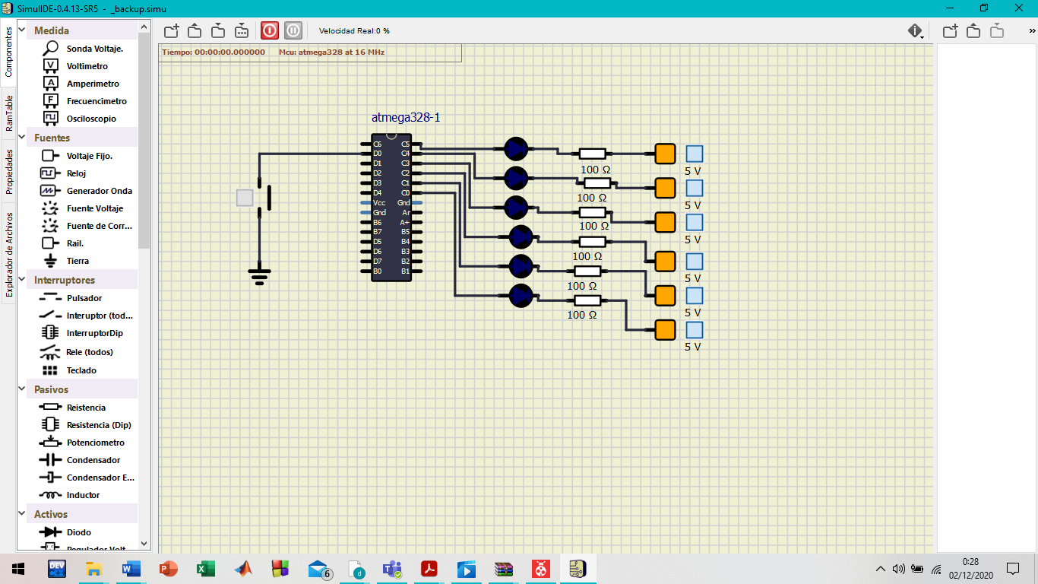

The difference between a normal function in c and an interruption, is that the normal function follows the order established in the code, when the call to the function arrives, then the function enters, in case of the interruption, is that when it arrives, it skips directly to the process regardless of the order.

* Table with PWM channels of ATmega328P

|  |  |  |  |
| --- | --- | --- | --- |
| Module | Description | MCU pin | Arduino pin |
| Timer/Counter0 | OC0A | PD6 | 10 |
|  | OC0B | PD5 | 5 |
| Timer/Counter1 | OC1A | PB1 | 9 |
|  | OC1B | PB2 | 10 |
| Timer/Counter2 | OC2A | PB3 | 11 |
|  | OC2B | PD3 | 3 |

